TRACTOR REGISTRATION FORM 2024

Melbourne Tractor Fest
21886 Melbourne Road
Melbourne, Ontario, N0L 1T0
519.319.1977
MelbourneTractorFest@gmail.com


TRACTOR APPLICATION FORM

POINT OF CONTACT NAME |  |  | CELL PHONE NO
COMPANY OR FARM NAME |  |  | HOME PHONE NO
TRACTOR BRAND |  | MODEL | YEAR
ADDRESS
CITY | POSTAL CODE | VENDOR EMAIL
FACEBOOK ID | TWITTER ID | WEBSITE

REQUESTOR / VENDOR’S NAME | SIGNATURE | DATE REQUESTED / SENT

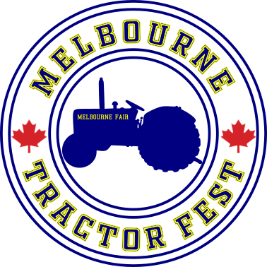

INTERNAL USE ONLY | VENDOR ID | DATE RECEIVED | DATE PAYMENT PROCESSED

